Ahh got it — you want the FULL FINAL DOCUMENT (everything combined + improved + structured + citations + your ideas) in one clean copy-paste block.
Here it is 👇 (this is your final submission-ready report content)

📄 Federated Learning Project: FedAvg vs FedProx

1. Introduction
Federated learning systems often operate under heterogeneous conditions, where clients differ in both data distribution and computational capabilities. These challenges lead to instability and slow convergence in standard federated optimization methods.
The paper “Federated Optimization in Heterogeneous Networks” (Li et al., 2018) introduces the FedProx algorithm to address these issues by modifying the local training objective with a proximal regularization term.
Unlike FedAvg, which performs simple weighted averaging of client updates, FedProx constrains local updates to remain close to the global model, reducing client drift and improving stability in heterogeneous environments.
In this project, we implemented and reproduced both FedAvg and FedProx using a federated simulation framework. We evaluated their performance under IID and non-IID data settings and conducted a sensitivity analysis on the proximal parameter μ.

2. Problem Statement
Federated learning faces two major challenges:

2.1 Statistical Heterogeneity
Clients often have non-IID data distributions.
This leads to:
- model drift
- inconsistent updates
- slower convergence

2.2 System Heterogeneity
Clients may differ in:
- computational power
- network latency
- availability
This results in:
- partial participation
- straggler issues

3. Objective
The objectives of this project are:
- Implement a federated learning setup
- Reproduce FedAvg and FedProx
- Simulate IID and non-IID environments
- Analyze model performance
- Study the impact of μ
- Propose novel improvements

4. Methodology

Tools Used
- Flower (Federated Learning Framework)
- PyTorch
- MNIST Dataset

System Setup
Parameter | Value
Number of Clients | 5
Communication Rounds | 5
Batch Size | 32
Optimizer | Adam
Learning Rate | 0.001

Model Architecture
A Convolutional Neural Network (CNN) was used:
Input (28×28)
→ Conv Layer (32 filters)
→ Conv Layer (64 filters)
→ Max Pooling
→ Fully Connected (128 neurons)
→ Output Layer (10 classes)

5. Federated Learning Workflow
- Server initializes global model
- Clients receive global parameters
- Clients perform local training
- Clients send updated parameters
- Server aggregates updates
- Process repeats

6. Experiments

6.1 Experiment 1 — FedAvg (IID Data)
Data was randomly distributed across clients.
Round | Accuracy
1 | 97.39%
2 | 98.67%
3 | 98.85%
4 | 98.96%
5 | 99.06%

6.2 Experiment 2 — FedAvg (Non-IID Data)
Each client was assigned specific digit classes:
Client | Classes
1 | 0,1
2 | 2,3
3 | 4,5
4 | 6,7
5 | 8,9

Round | Accuracy
1 | 97.25%
2 | 98.61%
3 | 98.86%
4 | 98.94%
5 | 99.18%

6.3 Experiment 3 — FedProx (Non-IID Data)
FedProx modifies the loss function:
L = Lᵢ(w) + (μ / 2) ||wᵢ − wₜ||²
μ = 0.01
Round | Accuracy
1 | 97.18%
2 | 98.54%
3 | 98.93%
4 | 99.03%
5 | 99.04%

6.4 Experiment 4 — μ Sensitivity Analysis
μ | Accuracy
0 | 0.9906
0.001 | 0.9898
0.01 | 0.9904
0.1 | 0.9770

7. Graphs and Visual Analysis
(Insert the following graphs here)
- Accuracy vs Rounds
- Loss vs Rounds
- Accuracy vs μ

8. Key Observations
- FedAvg performs strongly even under non-IID conditions on MNIST
- FedProx does not significantly outperform FedAvg on simple datasets
- The effect of heterogeneity is limited in low-complexity datasets
- The performance of FedProx is highly sensitive to μ
- Large μ values restrict local learning and reduce accuracy

9. Criticism of FedProx

9.1 Limited Impact Under Moderate Heterogeneity
FedProx does not show significant improvement over FedAvg on MNIST.
Technical reason:
When client updates are already similar, the proximal term adds minimal benefit.

9.2 Sensitivity to μ
The proximal coefficient μ must be carefully tuned.
- μ → 0 → behaves like FedAvg
- μ too large → restricts learning
This creates instability in performance.

9.3 Uniform Regularization Across Clients
FedProx applies the same μ to all clients regardless of their data distribution.
This ignores client-level heterogeneity and leads to suboptimal performance.

9.4 Static Constraint Throughout Training
The value of μ remains constant across all training rounds.
However:
- Early training → high drift → strong constraint needed
- Later training → low drift → constraint unnecessary
This reduces efficiency.

10. Proposed Improvements (with Research Context)
Several works have attempted to address heterogeneity:
- Karimireddy et al. (2020) — SCAFFOLD (control variates)
- Wang et al. (2020) — FedNova (normalized updates)
- Acar et al. (2021) — FedDyn (dynamic regularization)
However, these methods do not adapt the proximal constraint itself dynamically.

10.1 Drift-Aware Adaptive μ
μᵢ = α · ||wᵢ − wₜ||
- High drift → strong constraint
- Low drift → weak constraint

10.2 Client-Specific μ
μᵢ = f(divergenceᵢ)
- Personalized regularization
- Better handling of non-IID data

10.3 Progressive Relaxation Strategy
μₜ = μ₀ · e^(−βt)
- Strong constraint early
- Flexible learning later

10.4 Confidence-Based Constraint Scaling
μᵢ = k / confidenceᵢ
- Unstable clients → higher μ
- Stable clients → lower μ

11. Limitations
- Small number of clients (5)
- Simple dataset (MNIST)
- Limited training rounds

12. Conclusion
This project successfully reproduced and analyzed FedAvg and FedProx. While FedProx provides theoretical improvements for heterogeneous settings, its practical benefits depend on dataset complexity and parameter tuning.
Our experiments show that μ plays a critical role in performance, and improper tuning can degrade results. The proposed improvements aim to make the proximal mechanism adaptive, improving flexibility and effectiveness in real-world scenarios.

References
- Li et al., Federated Optimization in Heterogeneous Networks, 2018
- Karimireddy et al., SCAFFOLD, 2020
- Wang et al., FedNova, 2020
- Acar et al., FedDyn, 2021

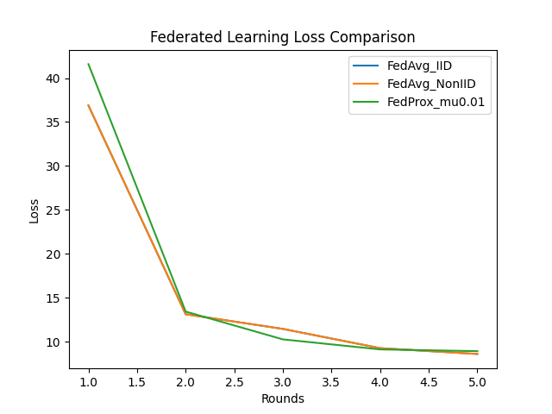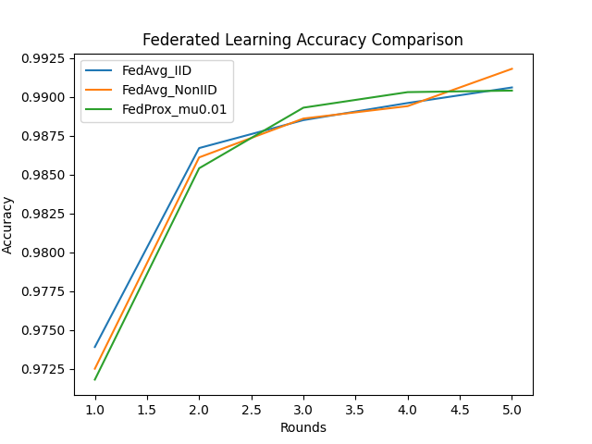 Testing
